**About**

Na samej górze:

Trully inspiration to establish ANON was very small and homeless cat which was adopted by the Edith. Over time, a friendship which developed between her and her cat, made her an animal lover. From that time she began to think there must be many other animals who need love and help from people. After a few months she adopted next homeless cat, but it wasn’t enough to sleep well again. She felt she can do more and needs to act to improve the fate of every animals on our planet. Nowadays, she works hard to achieve it - that is how the ANON was created. Of course, she is not alone in this, because love and care are contagious. She is supported by the wonderful ANON community, divided into 4 sections, dealing with different tasks. If you want to know more about ANON, please read the document below:

I tu wstawiamy promocyjny w wersji angielskiej (Załącznik nr 1) - **LINK do pobrania.**

Poniżej tego dokumentu wrzucamy akapit o treści ....obok zdjęcia...... z moim zdjęciem na stronę:

The Creator of ANON

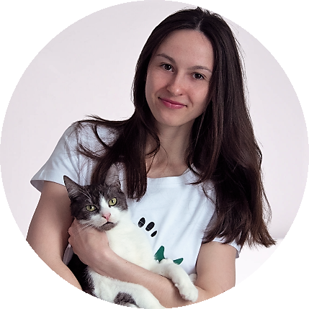Edith - a molecular biologist and teacher from Poland

*A lot of people doesn’t know or understand that animals are similar to us – they are more inteligent, full of emotions and fragile than we expected, which show a many of research (i learned it form my cat Bruce). That is why we should protect them as we protect ourselves. We can do that only by educate the people, raising the level of awareness about how much they suffer, because we don’t care enough and finally – change the law.*

